Januarry 2002
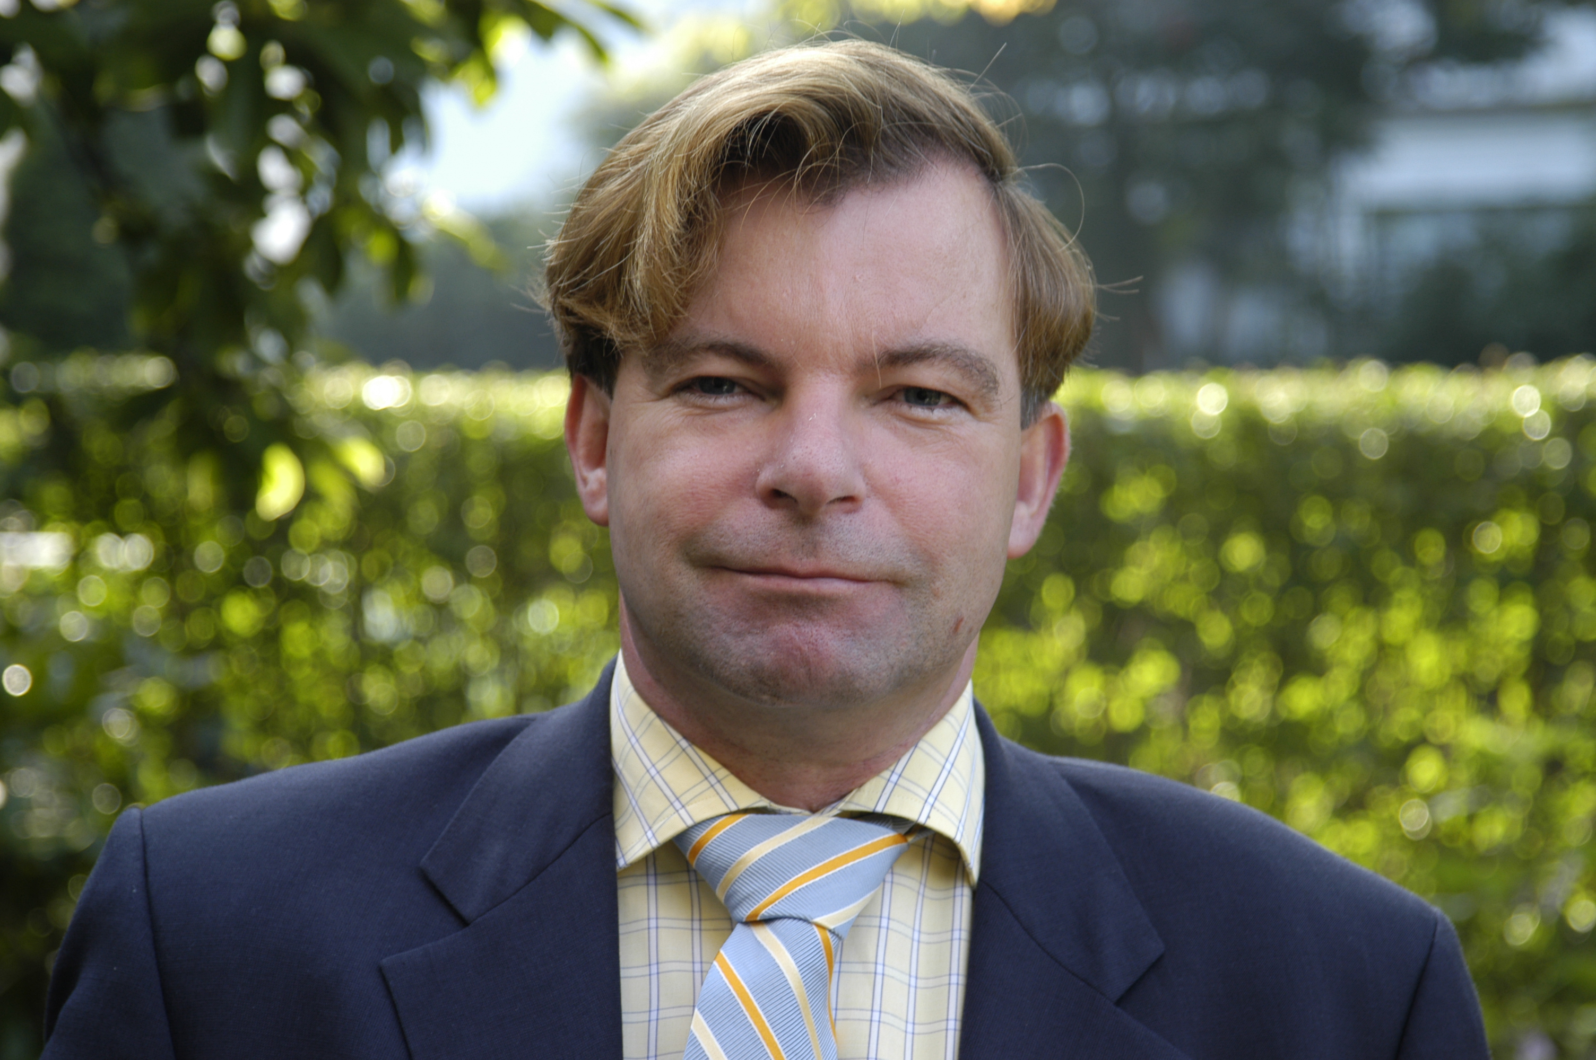

Curriculum Vitae Nico H.G. Baken

Nico Baken was born the 2nd of July ‘55 in Eindhoven, The Netherlands. He received his graduation of the gymnasium β in '73 and graduated, cum laude, in mathematics from the Technical University of Eindhoven, where he received the M.Sc. degree in 1981.

During his studies he made a mathematical model of double-heterostructure injection lasers to simulate their operation as a function of the various device parameters; this work was done at the Philips Research Laboratories and has been applied successfully to improve the laser design and performance. For his master thesis he investigated the elasto-plastic behaviour round crack tips in metal. He was involved as a student-member in the Committee Education of Mathematical Engineers and practised sports like bicycling, hockey, sailing (and in fact has built his own sailing-yacht with two friends), karate and judo; for the latter sport he was active in the organisation of tournaments at the TU Eindhoven. During his military service he was involved, as a reserve officer, in the software development for the artillery (KMA, Breda and FEL TNO in the Hague); final rank: first lieutenant.

In December 1982, he joined the PTT Research Neher Laboratories where his main research interest concerned Fibre Optics and the propagation characteristics of integrated-optical waveguides embedded in stratified media. Through this work he became actively involved in the European research project COST 216: "Optical Switching and Routing Devices" and the project RACE 1019: "Polymeric Optical Switching". He published over 20 papers, holds several patents and won two prices for his Scientific work: the Dr Neher Laboratory-price (yearly price for the most outstanding researcher) and the Veder-price. He completed his scientific career at the Neher Laboratory with a dissertation and Master Thesis from the University of Delft at the department of Electrical Engineering, promotor Prof. dr ir. H. Blok.

In addition to the scientific work at the Neher Laboratory, he was a secretary of the BECOM, a policy co-ordination board between Philips and PTT Telecom, also he has been made responsible to lead and co-ordinate the PTT taskforce "Exploration of Future Telecom Systems", an assignment from the board of directors. Finally, he organised for nearly three years the lecture program of the "Dutch Association of Electrical and Radio Engineers: NERG".

In april 1991, he started working at PTT Telecom, Network Services. First within the strategy department, where he was responsible for the Masterplan Fiber In The Local Loop. In 1993, within the department of the network operator, he was responsible for the transformation of this plan into commercial, technical and operational guidelines constituting the Telecom policy for the introduction of fiber in the Local Loop. In 1994, these guidelines were the actual basis for the automated production of blueprints for FO networks in all major cities in the Netherlands. In 1995 he was made responsible for the organisation of the actual roll out of these networks and became senior project-manager for the development and implementation of a Fiber In The Local Loop in the Netherlands. Within the context of Unisource (Telia, Swiss Telecom and PTT Telecom) he led the contribution of PTT Telecom in the Kernel Group Access Network; the work of this group involved e.g. the initiation of a Fiber To The Curb pilot and studies on wireless access.

At the end of 1995 he was asked to prepare the introduction of Asynchronous Transfer Methodology within NWD through organising the ATM programme, which is now running and amongst others comprises a large Research programme (40 man-years), national and international projects. The latter since he also holds a responsibility to co-ordinate the ATM activities within the Unisource Alliance. In fact, he led the production of a roadmap for the harmonisation of the current ATM platforms and the migration towards a ‘Unisource Alliance’s Second Generation Common ATM Platform’. The execution of the actions of roadmap led to an Request for Information, an EC-call, and (in august 1997) to a world-wide Request for Quotation.
In oktober 1996 he was elected as the best speaker at the 36th European Telecommunications Congress of FITCE in Vienna combining the topics Local Loop and ATM. At this point in time, he also became involved in the initial plans of Het Net, and the start up of the business unit InterNet Diensten. In may of 1997, he was asked to lead a Network Architecture and Service taskforce to design the future architecture of Het Net, comprising the narrow- and broadband dial in part (the latter with the use of ADSL), the transport (SDH/ATM) backbone and the IP-backbone. In August 1997, he was asked to accelerate and lead the start up of the second and third tranche of het Net, comprising 150.000 narrow band Internet ports and 50.000 broadband ADSL modem pairs.
In 1998, besides the work in the ATM field, working out a strategic vendor relation and the organisation of a Unisource Alliance’s Workshop on the crucial topic ATM and or IP will be on the list.
End of 1998 a new role as linemanager of group of senior architects for BroadBand Access and IP started, evolved in designing the Multi-Service Platform (next Generation Networks) for KPN within the department Network Design. Currently, he is also involved in FTTX and the kenniswijk projects in the Netherlands, the access network in a broader sense, cross-border lease constructions and real-estate management. In may 2001, he has been appointed as a part-time professor at the University of Delft in the field of Telecommunications.

In addition to this work he has been a member of the taskforce Integrated Network Architecture that developed a portfoliomodel for Telecom, comprising business modelling and the interaction between commercial, technical and operational issues. Also was he a member of the taskforce Vision Access Network. Furthermore, he is an alumnus of the London Business School.

In his social life, Nico is a husband, married to Charlotte van den Biggelaar, and father of two sons: Peter-Pim. and Jan-Joris.

This network is rolled out to facilitate the Internet Access for Internet Service Providers to the WWW and comprises both Dial-In services as well as Internet Access Services.

